**9 SCIENCE CHEMISTRY ASSIGNMENT: URANIUM 2016**

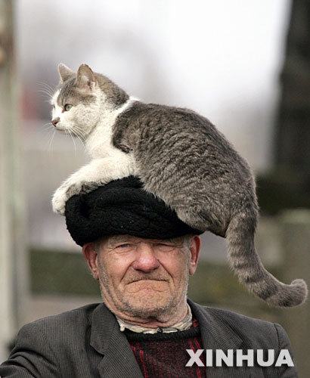

Name:__________________________ Teacher: _____________________

Form:__________________________ Due date: 4pm Wednesday 6th April

**Aim:** This assignment is based on the documentary: Uranium: Twisting the Dragon’s Tail, Part 2.

Host and physicist Dr. Derek Muller unlocks the mysteries of uranium, one of the Earth’s most controversial elements. Dr. Muller embarks on an epic journey across the globe to explain the fascinating details of uranium’s birth and longevity. Born from the collapse of a star, uranium has brought hope, progress and destruction.

**Video:** Uranium: Twisting the Dragon’s Tail Part 2: 54:53min

http://www.dailymotion.com/video/x31jrpz

**Plagiarism:**

You must write in your own words not copy sentences word for word from another student or another source.

Plagiarising = instant zero on assignment and you will have to re-do it.

**Assessment policy:**

Give me a sick note/legitimate reason from parent BEFORE due date = new negotiated due date.

One day late = -20% taken off mark

Two days late = -40% taken off mark

Three days late = mark of zero given

After three days, students are required to attend a detention and are still required to submit the assignment.

**If you are not at school the day this assignment is due,**

**please email it to me by 4pm.**

**___________________________@aranmore.wa.edu.au**

**Chernobyl disaster**

1. On what date did America drop a uranium bomb on the city of Hiroshima, Japan? (1 mark)

_________________________________________________________________________________________________

2. On what date did America drop a uranium bomb on the city of Nagasaki, Japan? (1 mark)

_________________________________________________________________________________________________

3. On what date did the Chernobyl disaster occur? (1 mark)

_________________________________________________________________________________________________

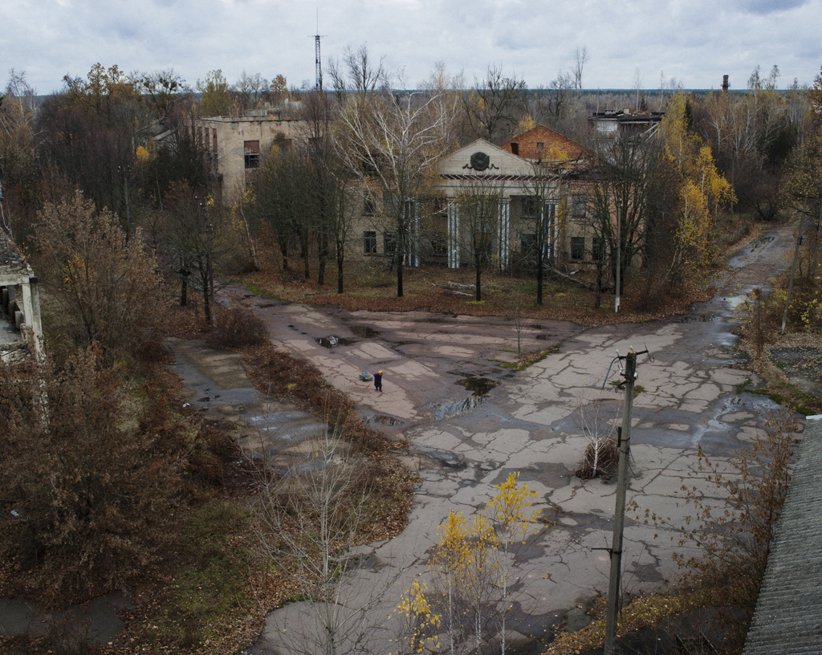*One of the atomic reactors was damaged and radiation was released across Europe. Soldiers were ordered to smother the reactor and the Chernobyl firemen were the first on the scene. They were then taken to hospital where they eventually died. The city and countryside around the reactor remains an abandoned exclusion zone: The Chernobyl Exclusion Zone, Ukraine.*

*Medical physicist who works in nuclear medicine (Bionerd) and who has been to the exclusion zone a number of times before, traveled with Dr Derrek Muller to the Chernobyl Exclusion Zone.*

4. What is the device called that detects radiation? (1 mark)

_________________________________________________________________________________________________

5. What is radiation measured in? (1 mark)

_________________________________________________________________________________________________

6. Describe what natural background radiation is and state what amount it is on average per hour. (2 marks)

_________________________________________________________________________________________________

_________________________________________________________________________________________________

_________________________________________________________________________________________________

_________________________________________________________________________________________________

_________________________________________________________________________________________________

_________________________________________________________________________________________________

_________________________________________________________________________________________________

7. Fill in the missing words below. (5 marks)

Bionerd and Dr Derrek Muller visit ____________, an abandoned town in the Chernobyl Exclusion Zone.

Visitors are allowed into the town but only for brief periods and never overnight. About 50 000 people lived here, mostly workers at the nuclear power plant and their families.

Nuclear reactors split uranium ___________, they smash them into fragments and that releases __________ which is how they generate electricity. When uranium atoms smash they break into smaller fragments and when the Chernobyl reactor blew, it spread those fragments across the city like dust.

The coating of smashed uranium atoms is not coated evenly over the city so there are ________ spots, which are really dangerous, even lethal.

The radiation is ____________________________. You can’t feel it, you can’t smell it or see it.

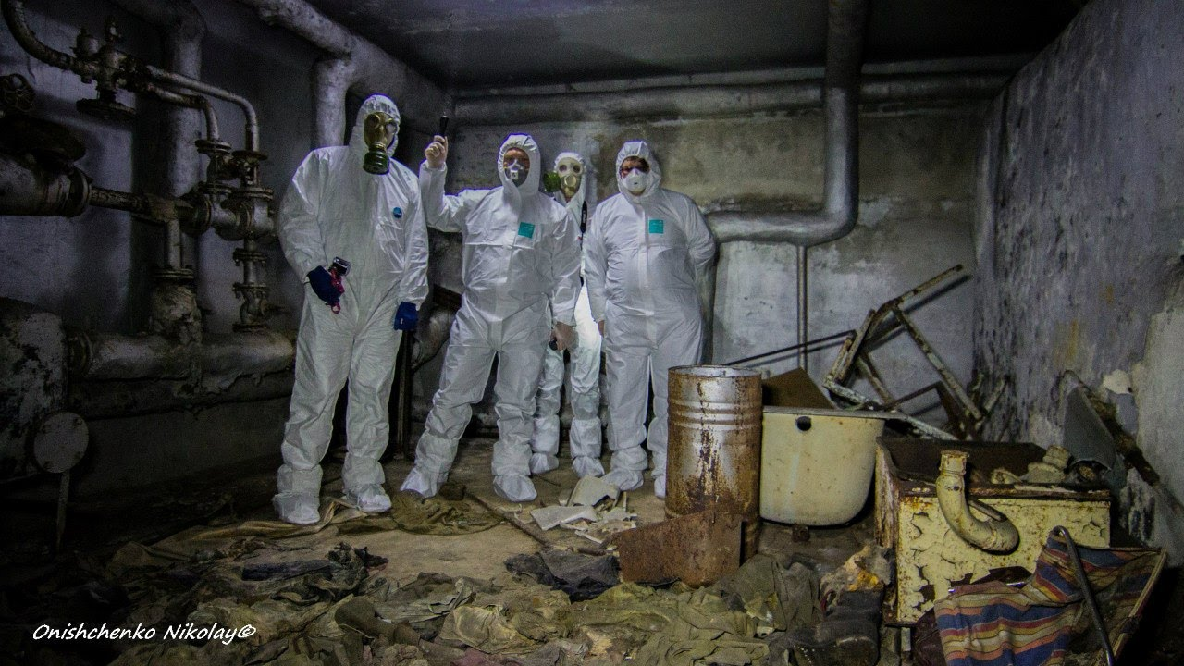*Bionerd and Dr Derrek Muller explored the hospital where the firemen were taken after they fought the fires at the Chernobyl reactors. Their clothing was still in the basement. Radiation in the basement may be 10000 times the natural background radiation, which is dangerous and why they used protective coverings and masks. They did not want to breath in or ingest the radiation.* *The main radiation in the hospital was from one particular fragment of split uranium atoms called caesium-137.*

8. Caesium-137 is a radioisotope of caesium. Explain what this means (minimum of three sentences) (3 marks)

_________________________________________________________________________________________________

_________________________________________________________________________________________________

_________________________________________________________________________________________________

_________________________________________________________________________________________________

_________________________________________________________________________________________________

_________________________________________________________________________________________________

_________________________________________________________________________________________________

_________________________________________________________________________________________________

_________________________________________________________________________________________________

9. Fill in the table below comparing caesium and caesium-137. (10 marks)

|  |  |  |  |  |  |
| --- | --- | --- | --- | --- | --- |
| Substance | Symbol | Atomic  number | Number of  protons | Number of  neutrons | Number of  electrons |
| Caesium |  |  |  |  |  |
| Caesium-137 |  |  |  |  |  |

*Bionerd and Dr Derrek Muller stayed in the basement for only four minutes but that was enough. If they stayed down there for an hour, they would have been exposed to the amount of radiation you would normally receive throughout one year.*

10. Explain why receiving your dose of radiation all at once is much worse than having it spread throughout the year (in full sentences). (1 mark)

_________________________________________________________________________________________________

_________________________________________________________________________________________________

_________________________________________________________________________________________________

11. List two (2) biological effects of being exposed to high doses of radiation. (2 marks)

_________________________________________________________________________________________________

_________________________________________________________________________________________________

_________________________________________________________________________________________________

**Half-life**

12. In your own words, explain what ‘half-life’ refers to (minimum of two sentences). (2 marks)

_________________________________________________________________________________________________

_________________________________________________________________________________________________

_________________________________________________________________________________________________

_________________________________________________________________________________________________

_________________________________________________________________________________________________

_________________________________________________________________________________________________

13. What is the half-life of caesium-137? (1 mark)

_________________________________________________________________________________________________

14. What is the half-life of uranium-238? (1 mark)

_________________________________________________________________________________________________

15a. State the name given to the confinement structure that encases the damaged nuclear reactor. (1 mark)

_________________________________________________________________________________________________

b. Explain why the new confinement structure is only a temporary solution (minimum of two sentences).

(2 marks)

_________________________________________________________________________________________________

_________________________________________________________________________________________________

_________________________________________________________________________________________________

_________________________________________________________________________________________________

_________________________________________________________________________________________________

_________________________________________________________________________________________________

16. It’s been about 30 years since the Chernobyl accident. Explain why people will not be able to live in Pripyat, Ukraine for hundreds of years (minimum of two sentences). (2 marks)

_________________________________________________________________________________________________

_________________________________________________________________________________________________

_________________________________________________________________________________________________

_________________________________________________________________________________________________

_________________________________________________________________________________________________

**Medical use**

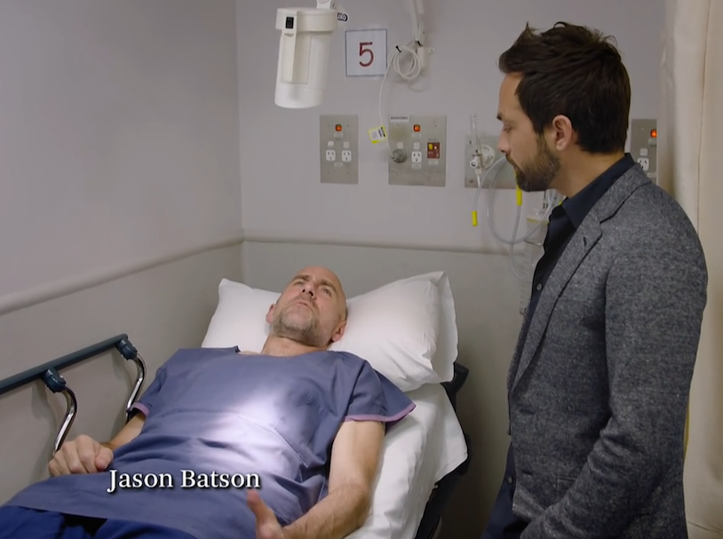

*Australia’s one and only nuclear reactor is housed at the Australian Nuclear Science and Technology Organisation in Sydney. This is not a power reactor but a research reactor where they create medicine and technology. Highly radioactive technetium-99m was injected into Jason Batson which acts as a radioactive tracer. The machine detects the gamma rays and makes a picture of them as technetium-99m gathers where there are fast growing cells.*

17. State the name given to the type of scan that Jason had and describe the purpose of Jason having this scan. (2 marks)

_________________________________________________________________________________________________

_________________________________________________________________________________________________

_________________________________________________________________________________________________

_________________________________________________________________________________________________

_________________________________________________________________________________________________

18. State the half-life of technetium-99m. (1 mark)

_________________________________________________________________________________________________

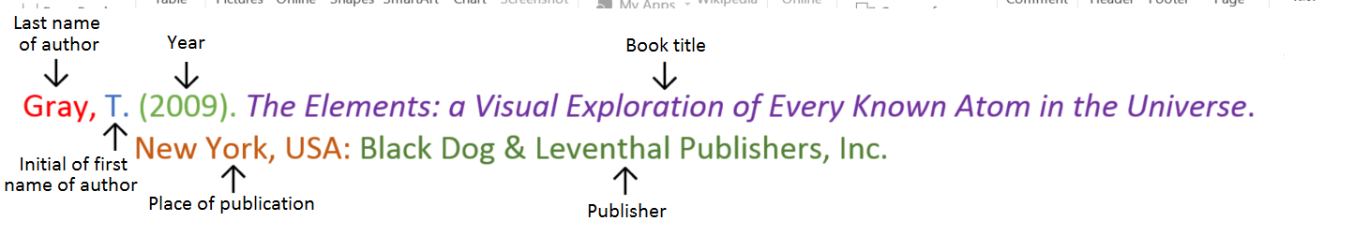**Book**

**Book with two authors**

Shermer, M., & Benjamin, A. (2006). *Secrets of Mental Math: The Mathemagician’s Guide to Lightning Calculation and Amazing Mental Math Tricks*. New York, USA: Three Rivers Press.

**Book with three or more authors**

Bulliet, R. W., Alley, R. B., Broecker, W. S., & Denton, G. H. (2011). *The fate of Greenland: Lessons from abrupt climate change*. Cambridge, MA: MIT Press.

**Book with editor**

Kasdorf, W. E. (Ed). (2003). *The Columbia guide to digital publishing*. New York, USA: Columbia University Press.

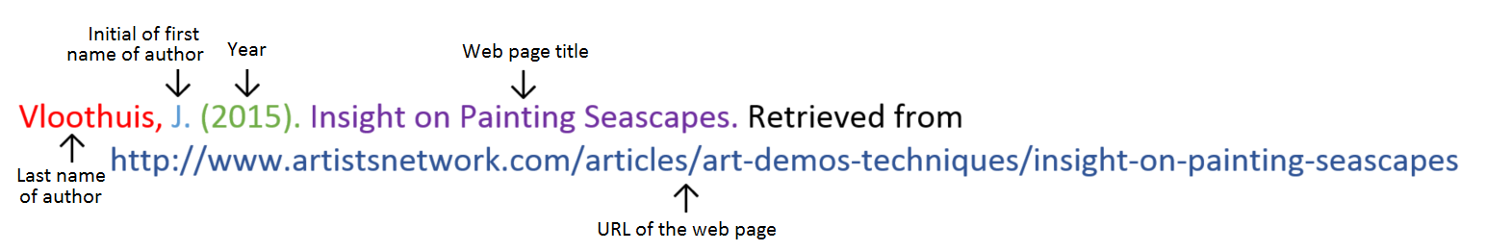**Website**

**Website with no author** (put title of page at the front)

Aranmore Catholic College. (2014). Retrieved from

http://www.aranmore.wa.edu.au/

**Website with no date**

The Zadkine Museum. (n.d). Retrieved http://www.france.fr/en/museums/zadkine-museum.html

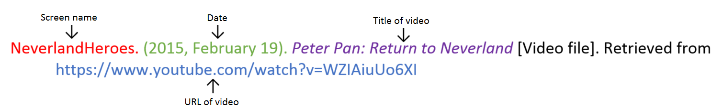**Video file**

**Reference list**

Minimum of two references. (1 mark)

Referenced using the APA style shown on the previous page. (1 mark)

_________________________________________________________________________________________________

_________________________________________________________________________________________________

_________________________________________________________________________________________________

_________________________________________________________________________________________________

_________________________________________________________________________________________________

_________________________________________________________________________________________________

_________________________________________________________________________________________________

_________________________________________________________________________________________________

_________________________________________________________________________________________________

_________________________________________________________________________________________________

_________________________________________________________________________________________________

_________________________________________________________________________________________________

_________________________________________________________________________________________________

Assignment is neatly written or typed. (1 mark)

Correct grammar and spelling. (1 mark)

**Total mark: /44 %**

**Teacher comments:**

_________________________________________________________________________________________________

_________________________________________________________________________________________________

_________________________________________________________________________________________________

_________________________________________________________________________________________________